

FRONT END – PART 1
FLEX

Code: Flex Balls 1

We have some balls put inside the box ready to export. Currently the balls are arranged as follows -

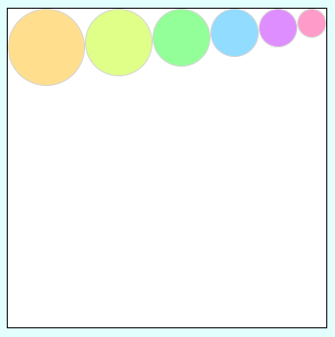
Before exporting them, some changes to the arrangement of these balls is needed.

First, reverse the order of these balls and it would look like this -

Now, rotate these balls 90deg in clockwise direction and it would look like this -

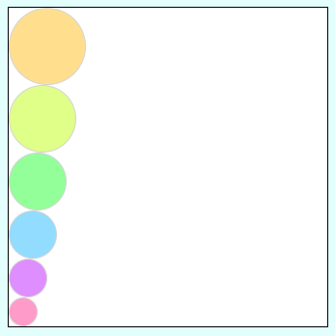

At last, change their sequence in the following manner -




